The mystery of the Cave Man photo
By Rhal Zahi. March 4, 2014

In this document it is reviewed one of the photos of the “Cave man” taken by Billy Meier, referred in the blog on the “Ufo-Prophet” web page here: (http://ufoprophet.blogspot.in/2014/02/the-cave-men-photos-controversy-outer.html#axzz2uuW7pyIN).

Main Conclusion: One picture taken by Billy Meier in 1975 is surprisingly very similar to the illustrations of the “March of Progress” poster produced in 1965 for the Time-Life Books (https://en.wikipedia.org/wiki/March_of_Progress).
But it is not the same image.

Key observations:

- Kal Korff explanation in his book is not solid, that Billy took a picture from a “visual monitor” and not from a real person (a cave man). He based his explanation on the rounded corner that the picture shows. In the photos taken with Billy’s camera, the corners are rounded (see figure 1 as an example).
- I am not sure that Kal Korff photo is “unedited” as the blog claims. It seems to me the original picture is bigger, and it is not confirmed if it is a real photo taken by Billy Meier. The photo arrived to Kal by a third party.
- If Kal Korff photo is taken from the original one, it is curious that there are no other details around the cave men, from the terrain, or the environment surrounding the cave men. In the contact notes, the image of the Cave men are cropped, so we do not see more details around them. It would be important in the future to obtain a full image copy from Billy Meier archives to make a better investigation.
- The illustrations from the “March of Progress” poster are very similar to Billy Meier photos. And, since they were produced 10 years before Billy took his pictures, it gives the impression that the theory that Billy took the pictures from this book might be correct. However, I have found it is not the same image as it will be explained here.
- If Billy took the pictures from the book, he must have used a mask to hide the other illustrations. There are no signs of a mask in the photos.
- Comparing the cave man on the right of Figure 2, it looks like the illustration from “March of progress” poster (referred as “Rudolph Zallinger”), shows a walking man, but to me his posture is not natural. Projecting the center of gravity of his body to the ground (figure 3), it falls in the middle of his feet. If this man is walking, the projection must fall towards the leading foot if he is transferring his weight to the front while walking. Billy picture shows a more natural movement, where the weight is projected towards his leading foot.
- The head of the cave man in the illustration from the poster is bigger than the one from Billy photo in the contact notes.
- I agree with Matt Knight comments that it is not the same image. Matt projected a few lines and compares other details in both images.
- If we rotate clockwise a fraction the illustration from the poster, we can align it better with Billy photo. See Figure 4. Now the illustration looks more natural, of somebody that is really walking.
- After rotating the image from the poster (Figure 4), we notice the projection of the center of mass of the man’s body, now falls into the same area on the ground. However, his left foot is now elevated, and it is not touching the ground. In Billy´s photo, the cave man has his left foot touching the ground.
- Since the illustration in the poster shows a bigger head of the cave man, and the left foot is elevated when comparing with Billy Meier photo, I conclude both images are not the same.
- Comparing the images from the poster, with the image from Kal Korff book, and with the image from the Contact Notes, they are not exactly the same (Figure 5). The position of the legs and feet are the same from the poster and Kal pictures, and the position of the head of the cave man in Kal picture and Billy Photo are similar. There is a possibility the Kal’s picture and the poster illustration are the same. Having a good copy of the photo that Kal received may confirm this.
- If the images are not quite the same, why they look very similar? Why an illustration made in 1965 shows a man very similar to a picture taken 10 years later? It is a coincidence? Why Kal photo is very similar to Billy’s but not the same, and it is very similar to the illustration on the poster? There are more questions here than answers. What is very clear is that Billy photos of the cave men (the ones in the Contact notes) were not taken from this illustration (the poster of the “March or the Progress”). Having a copy of original Billy’s pictures may give us more information, not only about the cave men, but the environment around them.

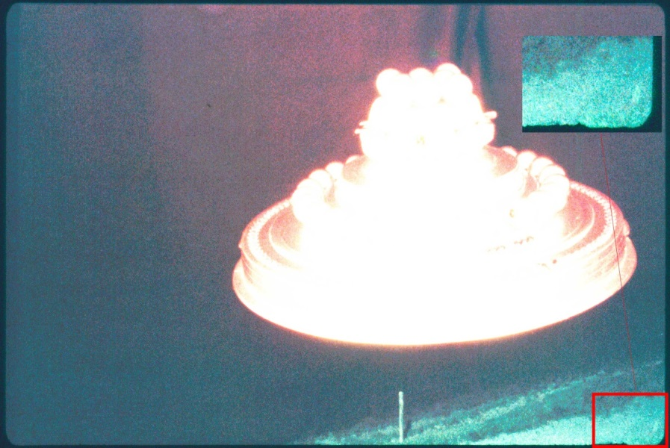

Figure 1- Example of a photo (WCUFO at night, enhanced).
It shows rounded corners as the Cave-Man picture (see detail)

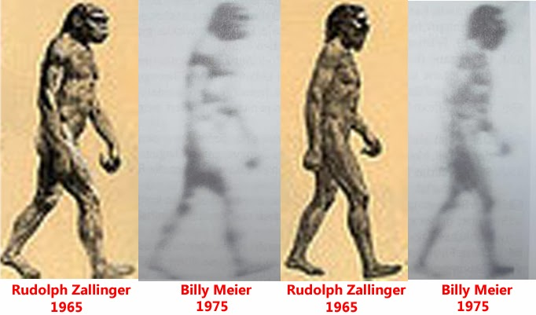
Figure 2 – Comparison of illustrations from the book and pictures taken by Billy.
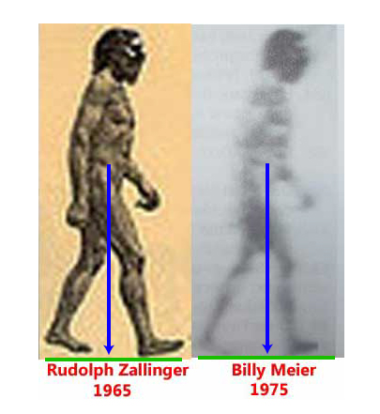
Figure 3 – Projection of the body center of mass. If the man is walking, the projection must fall towards the leading foot, not in the middle of the feet. Right image show a more natural posture.

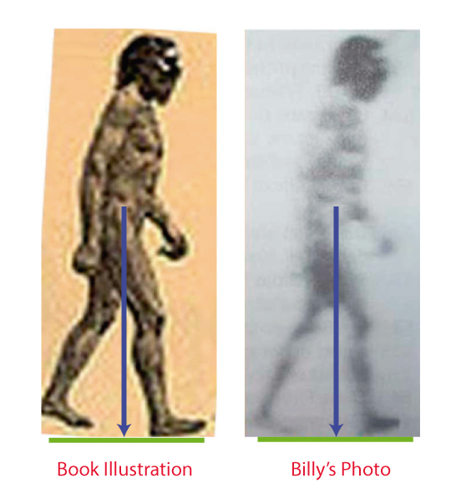
Figure 4 – Similar to figure 3, but left image is rotated clockwise. Now both images show a similar posture. However, the left foot on left image is elevated and his head is bigger. The photo on the right could not be taken form the illustration on the left
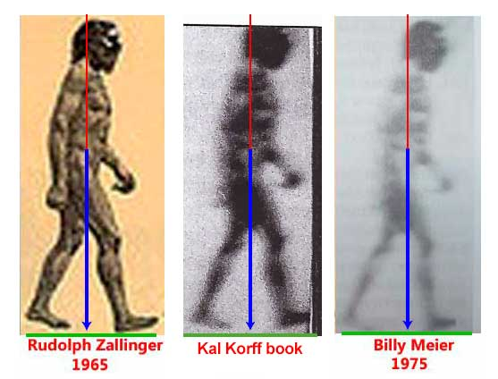
Figure 5 – Comparison of images of the Cave Man from the poster (left), Kal’s book (middle) and Billy picture from the Contact notes. The position of the legs on the poster and Kal’s picture are the same. The position of the head on Kal’s picture and Billy photo is about the same. There is a possibility that Kal’s picture and the illustration from the poster are the same image.

